Lab 1: Understanding ORM with a Retail Inventory System
Scenario:
You’re building an inventory management system for a retail store. The store wants to track products, categories, and stock levels in a SQL Server database.
Objective:
Understand what ORM is and how EF Core helps bridge the gap between C# objects and relational tables.
Steps:
1. What is ORM?
ORM (Object Relational Mapping) is a technique that maps C# classes to database tables. Instead of writing SQL queries manually for every database operation, developers can work directly with C# objects. The ORM framework automatically converts object operations into SQL commands and executes them on the database.
Example:
A Product class in C# can be mapped to a Products table in SQL Server. This reduces development effort and makes applications easier to maintain.
BENEFITS OF ORM
ORM provides several advantages that make application development easier and more efficient.
- Improved Productivity: Developers can work directly with C# classes and objects instead of writing large amounts of SQL code. This reduces development time and increases productivity.
- Better Maintainability: Changes made to classes can be reflected in the database structure through migrations. This makes the application easier to maintain and update.
- Database Abstraction: ORM hides many database-specific details from the developer. As a result, developers can focus on application logic rather than database syntax.
2. Compare EF Core and EF Framework
Entity Framework Core (EF Core)
- Cross-platform framework that works on Windows, Linux, and macOS.
- Lightweight and modular architecture.
- Provides better performance and optimized query execution.
- Supports modern .NET versions such as .NET 8.
- Includes advanced features like compiled models, JSON column mapping, and improved bulk operations.
- Actively developed and regularly updated with new features.
Entity Framework (EF6)
- Primarily designed for Windows environments.
- Larger and less modular compared to EF Core.
- Performance is comparatively slower.
- Mainly supports the traditional .NET Framework.
- Contains fewer modern features.
- Considered a mature framework but receives limited enhancements.
- Commonly used in older enterprise applications.
3. EF CORE 8.0 FEATURES
Entity Framework Core 8.0 introduces several improvements that help developers build faster and more efficient applications.
- JSON Column Mapping
EF Core 8.0 allows data to be stored in JSON format within database columns. Developers can query and update JSON data without manually parsing it. This feature is useful when working with semi-structured data.
- Compiled Models
Compiled models improve application startup time and reduce the overhead involved in creating entity models during runtime. This results in better performance, especially for large applications.
- Interceptors
Interceptors allow developers to monitor, modify, or log database operations before or after they are executed. This is useful for auditing, security checks, and performance monitoring.
- Improved Bulk Operations
Bulk operations help process large amounts of data more efficiently. Tasks such as inserting, updating, or deleting thousands of records can be performed faster, improving overall application performance.
- Better Query Performance
EF Core 8.0 includes several optimizations that improve query execution speed and reduce database communication overhead.
4. Implementation:
1. Project Setup
I created a C# Console Application named RetailInventory using Visual Studio Community and selected the .NET 8 framework.
2. Installing EF Core Packages
To prepare the project for Entity Framework Core development, I installed the following NuGet packages:
Install-Package Microsoft.EntityFrameworkCore.SqlServer
Install-Package Microsoft.EntityFrameworkCore.Design
Package Purpose
Microsoft.EntityFrameworkCore.SqlServer
Provides SQL Server database support for Entity Framework Core.
Microsoft.EntityFrameworkCore.Design
Provides design-time tools required for migrations and other EF Core operations.
Output: Project Output and Installed Packages
The screenshot below shows:
- Successful installation of the required EF Core packages.
- Package Manager Console output.
- RetailInventory project structure.
- Dependencies > Packages folder expanded.
- Installed Entity Framework Core packages.
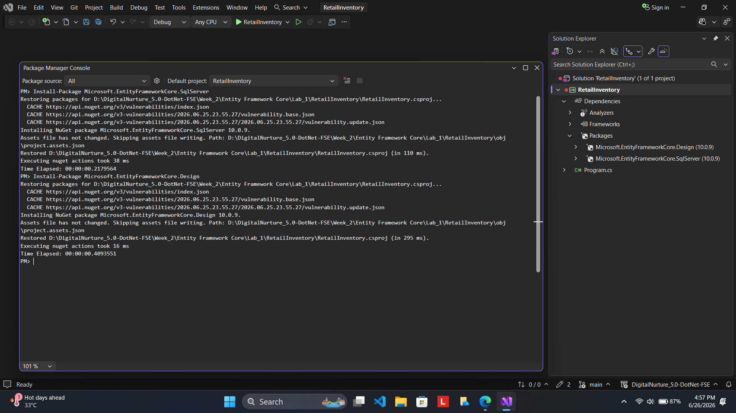
Look at the screenshot below:

